1. What is Web Scraping?
Web scraping means extracting information automatically from websites.
- Normally, when you visit a website (say, Amazon), you see a page built using HTML — which contains tags like <div>, <h1>, <p>, etc.
- A web scraper is a Python program that:
  - Sends a request to the website (just like your browser does),
  - Downloads the HTML code,
  - Extracts specific data from it (e.g., product names, prices, links),
  - Optionally saves it in a structured form (like Excel, CSV, or a database).
Use cases:
- Price tracking (e.g., mobile prices on Amazon)
- Research (e.g., collecting quotes or articles)
- Social media trend analysis
- Job postings, stock data, etc.
⚠️ Important: Always check the website’s robots.txt file (e.g., https://example.com/robots.txt) and Terms of Service before scraping. Some sites prohibit or limit scraping.

🧱 2. Static vs Dynamic Web Pages
Type | Description | How to Scrape
Static Page | The HTML contains all the data when you load it. | Use requests + BeautifulSoup.
Dynamic Page | The content loads later using JavaScript (AJAX). | Use Selenium (simulates a browser) or APIs.
Example:
- A static site might show <h2>Product: iPhone 14</h2> directly in HTML.
- A dynamic site may first load an empty <div> and later fill it via JavaScript — you’ll only see it in the browser, not in the HTML fetched by requests.
That’s why we need Selenium for dynamic pages — it actually renders the page like a browser.

1️⃣ What is BeautifulSoup?
BeautifulSoup is a Python library used to parse (analyze and navigate) HTML or XML documents.
It helps you extract data from web pages — like titles, links, tables, etc. — by providing easy-to-use functions to locate and manipulate elements in the HTML tree.
❌ BeautifulSoup doesn’t support XPath
Think of it as a browser inspector for your Python code.

🧩 2️⃣ How it fits into web scraping
Usually, we use these tools together:
Tool | Role
requests | Downloads the HTML page
BeautifulSoup | Parses that HTML to extract data
pandas (optional) | Stores data in CSV or DataFrame format
So, your workflow is:
- Send request → get HTML
- Use BeautifulSoup → find elements
- Extract text → clean data
- Save results

Common HTML Attributes You’ll Use in Web Scraping
Attribute | Description | Example Usage
id | Unique identifier for an element | <div id="main">
class | Groups elements with similar style/role | <p class="text">
href | Specifies link destination | <a href="https://...">
src | Specifies image or media source | <img src="image.jpg">
title | Tooltip / descriptive title | <p title="info">
alt | Alternate text for images | <img alt="logo">
data-* | Custom data fields (often used in modern sites) | <div data-price="500">

Installation and Basic Setup
pip install beautifulsoup4
Then in your code:
from bs4 import BeautifulSoup
import requests

url = "https://books.toscrape.com/"
response = requests.get(url)
soup = BeautifulSoup(response.text, "html.parser") # parse HTML
Now soup is your parsed HTML tree, and you can query it easily.

3️⃣ Basic Example
Let’s scrape a static page: https://quotes.toscrape.com
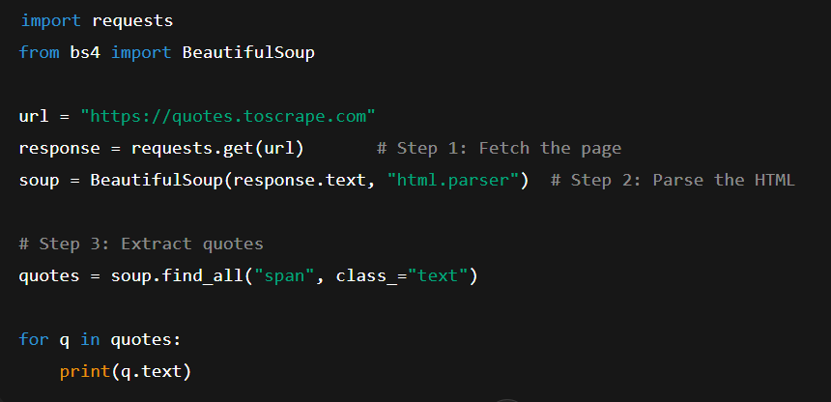
Output (sample):
“The world as we have created it is a process of our thinking.”
“It is our choices that show what we truly are, far more than our abilities.”
...
4️⃣ Main Parsing Functions
Let’s explore the core functions of BeautifulSoup.
We’ll use this small HTML snippet to understand how each works.
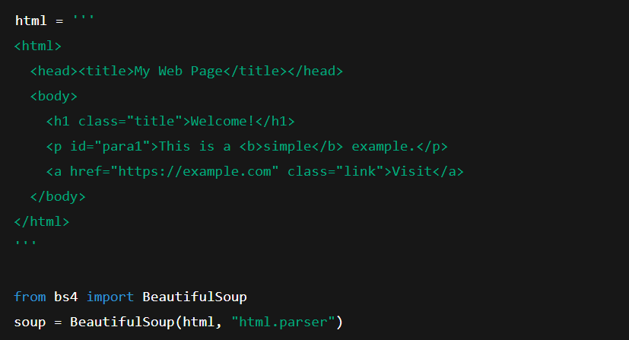
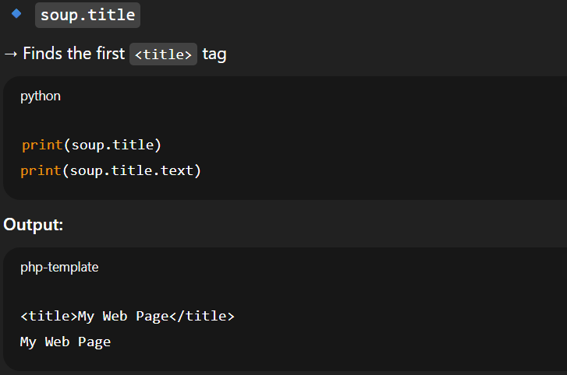

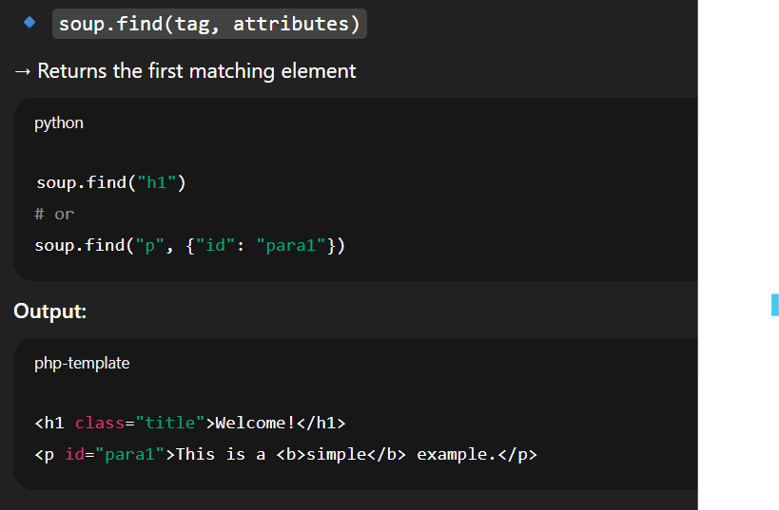

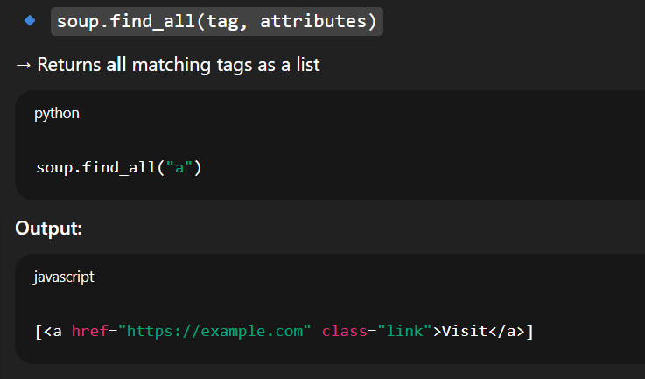

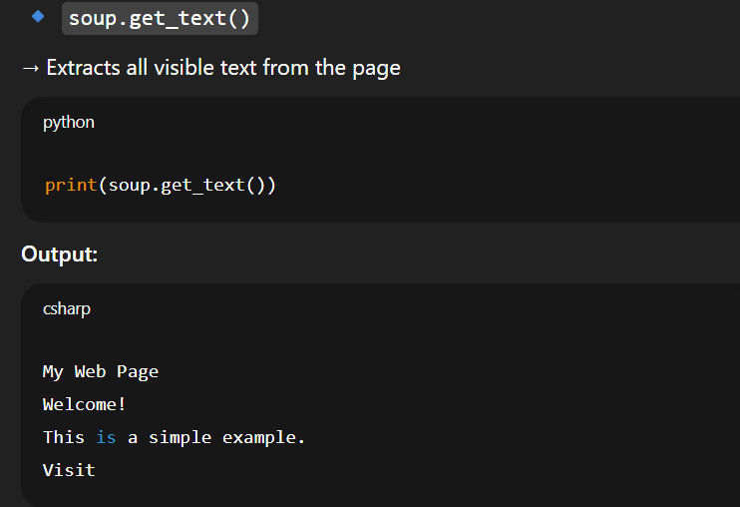

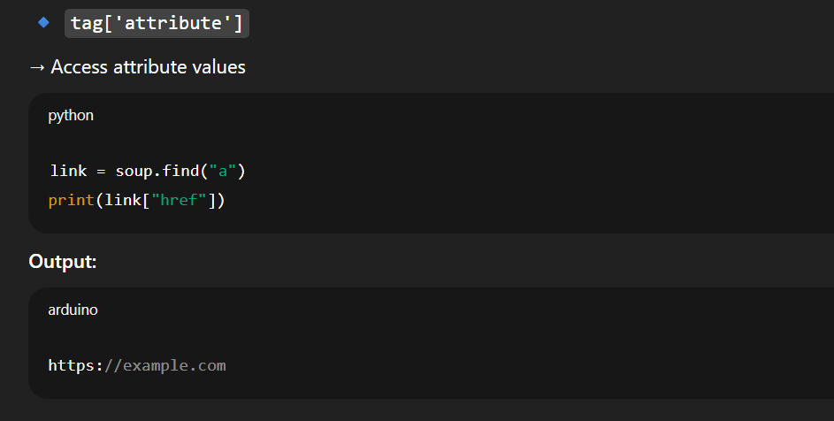

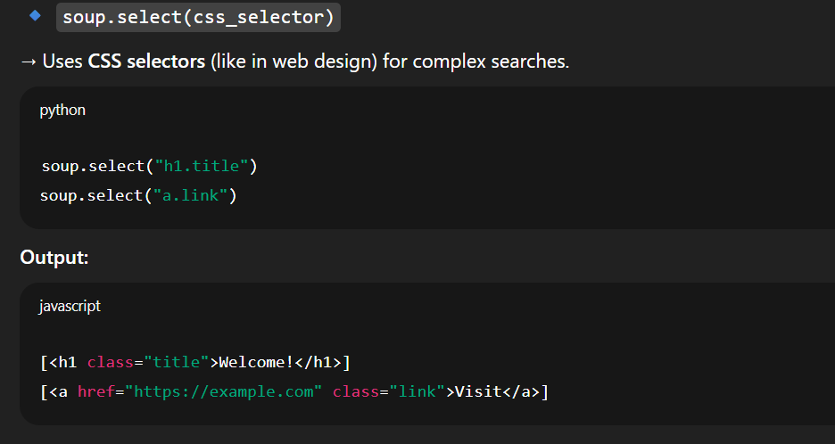

🧭 4️⃣ Core Components
1. Tag
Represents an HTML element like <div>, <a>, <p>, etc.
tag = soup.h1
print(tag.name) # 'h1'
2. NavigableString
The text inside a tag.
print(tag.string) # prints the actual text
3. BeautifulSoup object
The whole parsed document (root object).
print(soup.title.string)
4. Attributes
Tags often have attributes (like href, class, id).
link = soup.a
print(link['href']) # prints the link URL

🔍 5️⃣ Common Functions (used in 90% of scrapers)
✅ find()
Finds the first matching tag.
soup.find('h3')
✅ find_all()
Finds all matching tags — returns a list.
soup.find_all('a')
✅ select()
Finds elements using CSS selectors (powerful for nested structures).
soup.select('.product_pod h3 a') # class selector
✅ get_text()
Extracts text only (no HTML tags).
title = soup.find('h3').get_text()
✅ attrs or get()
Access attributes like href, src, etc.
link = soup.find('a')
print(link.get('href'))

🧩 6️⃣ Navigating the Tree
BeautifulSoup lets you move through parent/child relationships easily.
# Example structure
div = soup.find('div')

div.contents # returns all children
div.parent # returns parent tag
div.next_sibling # next HTML element at the same level
div.previous_sibling

⚙️ 7️⃣ Searching with filters
You can search by:
By Tag Name
soup.find_all('p')
By Class or ID
soup.find_all('div', class_='quote')
soup.find('span', id='author-name')
By Attributes
soup.find_all('a', attrs={'href': True})
By Text Content
soup.find_all(string='Albert Einstein')

⚡ Cleaning Extracted Data
Often, HTML contains unwanted spaces, symbols, or line breaks.
You can use:
text.strip() # removes extra spaces
re.sub() # remove unwanted characters using regex

